1. 12 .Aim :To Design DFA using simulator to accept the input string “a” ,”ac”,and ”bac”.

INPUT: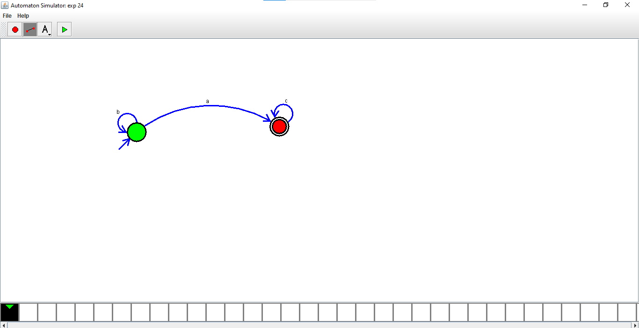

OUTPUT:

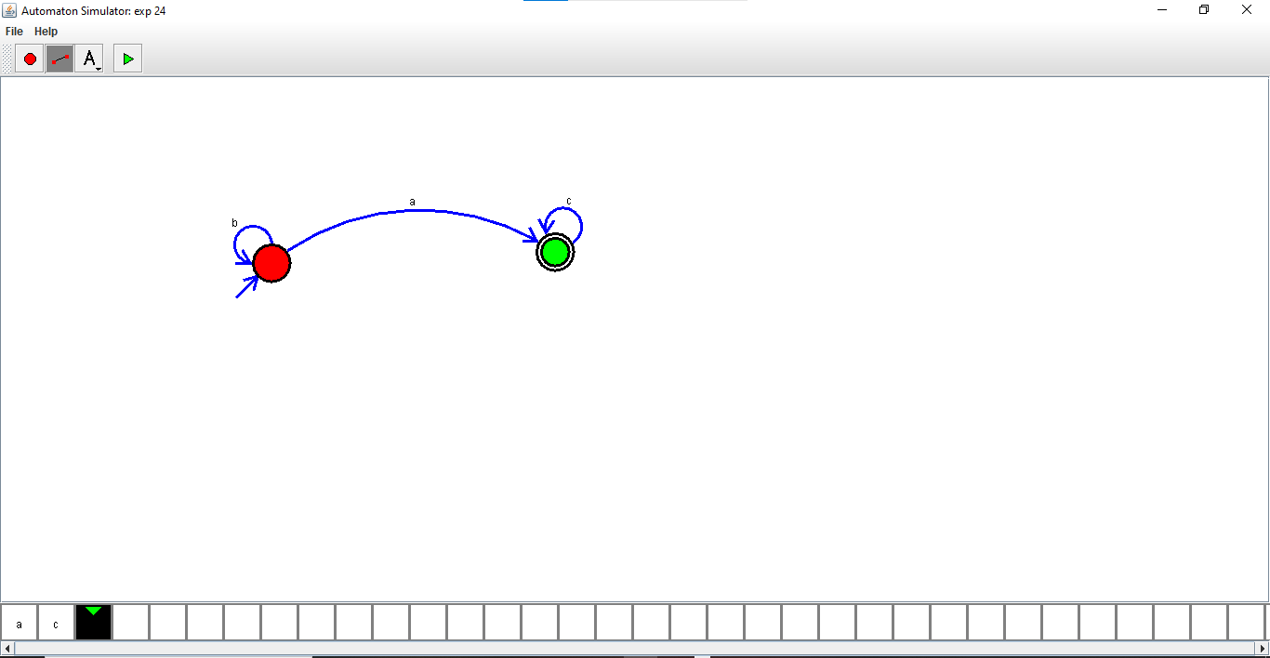

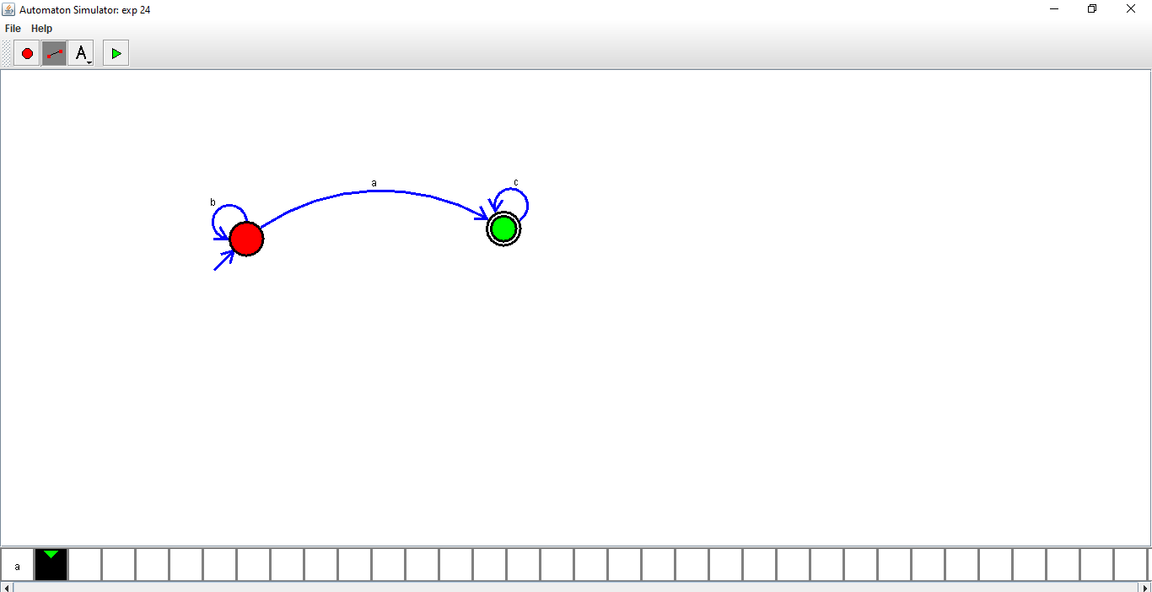



RESULTS:

Thus Designed DFA using simulator to accept the input string “a” ,”ac”,and ”bac”.